Title [Capitalize Only the First Letters of All Words Except for Coordinating Conjunctions, Articles, and Prepositions; Arial Bold 14 Point; Fixed 20 Point Line Spacing; Centering]
Your photo here (45 mm x 35 mm):
Color Photograph is welcome
Blank line [fixed 18 point line spacing]
Author [Times New Roman plain 14 point; fixed 18 point line spacing; centering]
Affiliation [Times New Roman italic 12 point; fixed 18 point line spacing; centering]
E-mail address of the lecturer [E-mail: xxxx@xxx]
Blank line [fixed 18 point line spacing]
Abstract (one page) [Times New Roman plain 12 point; fixed 18 point line spacing; justification; write the manuscript on an A4 paper (margins; 25 mm for right, left, top, and bottom) just as in this template. Insertion of figure(s) is allowed. Will be printed in color.]
Blank line [fixed 18 point line spacing]

References (up to three papers) [Times New Roman plain 12 point; fixed 18 point line spacing; left-aligned; Journal Title should be abbreviated in the NLM (Pubmed) manner (http://www.nlm.nih.gov/services/pm_title_abbrev.html) (or any manner if you cannot find appropriate abbreviations)]
[1] Author, B.; Author, C. D.; Author, E. J. Am. Chem. Soc. 2015, 137, XXX.
[2] Author, B.; Author, C. D.; Author, E. Angew. Chem., Int. Ed. 2016, 55, XXX.
[3] Author, B.; Author, C. D.; Author, E. Chem. Commun. 2014, 50, XXX.
Blank line [fixed 18 point line spacing]
Professional career (starting with the year of your degree reception, however not necessary for students)
2001 Ph.D., Univ. xxx, Country
2001-2002 Postdoctoral Fellow, National Institute xxx, Country
2002-2005 Assistant Professor, Univ. yyy, Country
2006-present Professor, Department zzz, University aaa, Country

Deadline: January 31, 2018.
# Please submit both MS Word file and PDF file.
# Please submit your photo as a separate file (JPEG or TIFF) as well.
# Will be printed in color.
Example of the Forum Talk Abstract
Your photo here (45 mm x 35 mm):
Color Photograph is welcome
Hiroyuki Nakamura
Laboratory for Chemistry and Life Science, Institute of Innovative Research, Tokyo Institute of Technology, Japan
hiro@res.titech.ac.jp

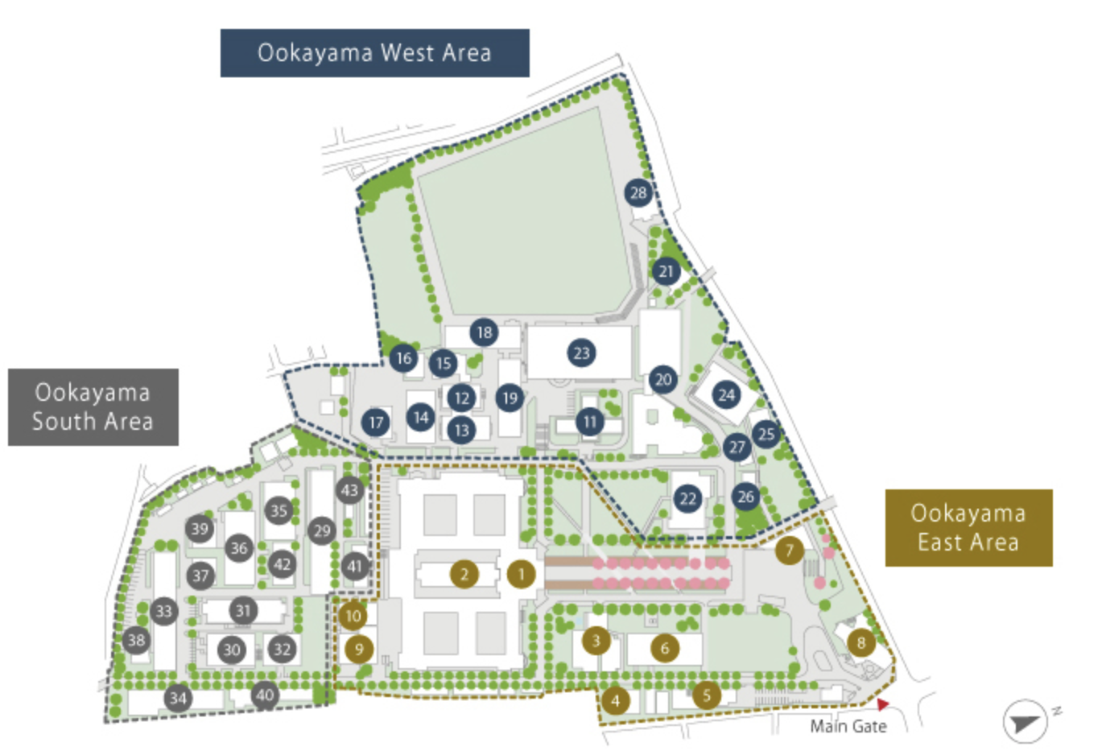
This is an example of the abstract for the International CLS Forum on Photo and Catalytic Science for Sustainable Society. Please write the abstract following this format, and kindly send it back by January 31. If you have any questions, please feel free to ask Hiroyuki Nakamura via email. We are looking forward to seeing you in March. This is an example of the abstract for the International CLS Forum on Photo and Catalytic Science for Sustainable Society. Please write the abstract following this format, and kindly send it back by January 31. If you have any questions, please feel free to ask Hiroyuki Nakamura via email. We are looking forward to seeing you in March. This is an example of the abstract for the International CLS Forum on Photo and Catalytic Science for Sustainable Society. Please write the abstract following this format, and kindly send it back by January 31. If you have any questions, please feel free to ask Hiroyuki Nakamura via email. We are looking forward to seeing you in March. This is an example of the abstract for the International CLS Forum on Photo and Catalytic Science for Sustainable Society. Please write the abstract following this format.
Figure 1. Ookayama campus map.

References
[1] Author, B.; Author, C. D.; Author, E. J. Am. Chem. Soc. 2015, 137, XXX.
[2] Author, B.; Author, C. D.; Author, E. Angew. Chem., Int. Ed. 2016, 55, XXX.
[3] Author, B.; Author, C. D.; Author, E. Chem. Commun. 2014, 50, XXX.

Professional career
2001 Ph.D., Univ. xxx, Country
2001-2002 Postdoctoral Fellow, National Institute xxx, Country
2002-2005 Assistant Professor, Univ. yyy, Country
2006-present Professor, Department zzz, University aaa, Country

